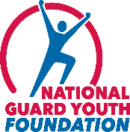 13th Annual ChalleNGe Champions Recognition Reception 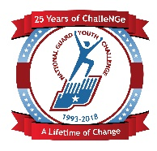

Celebrating the Youth ChalleNGe Program’s 25th Anniversary

SPONSORSHIPS OPPORTUNITIES

DIAMOND | $100,000+
Diamond level commitment encompasses both lead sponsorship of the reception and year-long programmatic partnership with NGYF.
- Promotional acknowledgement of partnership before, during, and after the reception across website, print, email, and social media campaign
- Recognition as presenting sponsor on all event signage and spoken program
- Reception networking (twelve attendees)
- Recognition in pre and post event press release and other press outreach
- Build branded initiative to support local ChalleNGe program

PLATINUM | $50,000+
- Promotional acknowledgement of sponsorship before, during, and after the reception across website, print, email, and social media campaign
- Reception networking (ten attendees)
- Recognition as sponsor on all event signage and spoken program
- Recognition in pre and post event press release and other press outreach

GOLD | $35,000+
- Promotional acknowledgement of sponsorship before, during, and after the reception across website, print, email, and social media campaign
- Reception networking (eight attendees)
- Recognition as sponsor on all event signage and spoken program
- Recognition in pre and post event press release and other press outreach

SILVER | $25,000+
- Reception networking (six attendees)
- Recognition as sponsor on all event signage and spoken program

BRONZE | $10,000+
- Reception networking event (four attendees)
- Recognition as sponsor on all event signage and materials

Your Tax-Deductible contributions can be made online www.ngyf.org or
Check mailed to: NGYF, One Massachusetts Ave, NW. Washington, DC, 20001 or
call Carol Henry at (703) 684-5437 for electronic transfer details

