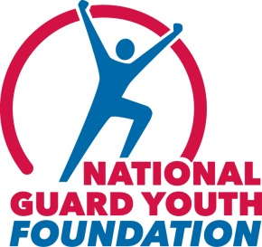
For Immediate Release:
June 24, 2013

Contact:
Ashley Saunders
703-684-5437
Dale Earnhardt Jr. Drives in Kentucky’s Quaker State 400 to
Jumpstart Awareness of High School Dropout Crisis
Dedicated to National Guard Youth ChalleNGe and the National Guard Youth Foundation,
Six Graduates will be Honored

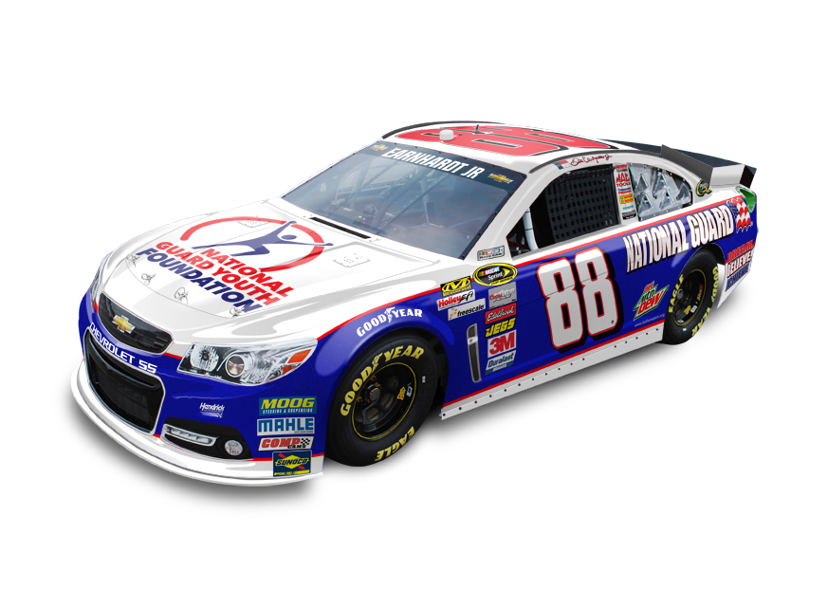

Alexandria, Va. – Dale Earnhardt Jr. has teamed up with the National Guard Youth Foundation (NGYF) to propel attention to the nation’s alarming high school dropout rate and to the National Guard Youth ChalleNGe program as a proven pathway back to graduation and road to continued success. Earnhardt Jr.’s No. 88 Chevrolet SS will highlight NGYF at the June 29 Quaker State 400 NASCAR Sprint Cup Series race at Kentucky Speedway, where ChalleNGe graduates will be special guests. The graduates also will be featured in a new public service announcement along with Earnhardt Jr.

“We’re honored to be involved with the National Guard Youth Foundation and help raise awareness of the problem of high school dropouts in our country,” said Earnhardt Jr., who drives the No. 88 National Guard Chevrolet SS for Hendrick Motorsports. “These are great kids, but they’ve fallen off the radar for any number of reasons. We have to give them the full attention they need and deserve. I’ve seen how the National Guard Youth Foundation and ChalleNGe do that and get them back on track, which is life-changing and so critical.”

“What Hendrick Motorsports, Dale Earnhardt Jr. and the National Guard Youth Foundation are doing on behalf of these kids is amazing,” stated Maj. Gen. Edward Tonini, adjutant general of Kentucky and member of the National Guard Youth ChalleNGe Program General Officer Advisory Council (GOAC) Board. “The Youth ChalleNGe program needs help garnering awareness to ultimately help more of our troubled youth…and events like this are just the ticket.”

Nearly 25 percent of U.S. students drop out of high school. Helping more than 115,000 teens to date turn their lives around, ChalleNGe – a 17-month education and workforce development program that culminates in high school graduation or attainment of a GED – is recognized as among the most cost-effective, highly rated programs of its kind for at-risk youth.
▪ An independent, multi-year study of the program by MRDC shows that high school diploma/GED attainment increase 29 percent, college attendance by 86 percent and annual earnings by 20 percent.
▪ An independent cost-benefit analysis by the RAND Corporation shows a 166 percent return on investment in the program – every dollar spent yielding a return of $2.66 in benefits to society.

“The National Guard Youth Foundation believes that every high school youth at risk of being lost or forgotten deserves a second chance,” said Gail Dady, president of the National Guard Youth Foundation Board of Directors. “Dropping out of high school creates a potentially devastating domino effect on the kids themselves, their families, communities and, ultimately, our nation. We are grateful for the support of Dale Earnhardt Jr. and Hendrick Motorsports for helping us raise awareness of ChalleNGe and the positive impact the program is having on the lives of youth in need.”

About the National Guard Youth ChalleNGe Program
The National Guard Youth ChalleNGe Program is a 17-month voluntary program serving 16- to 18-year-olds who have dropped out or are at risk of dropping out of school. The program – which includes a 5.5-month residential phase and 12-month mentoring phase – provides education, skills and guidance to help instill a sense of self-esteem, integrity and character to disadvantaged youth who might otherwise be left behind by society. There are 34 program sites in 27 states and Puerto Rico. Since its inception in 1993, more than 115,000 students have graduated from the program.
# # #

The National Guard Youth Foundation, a non-profit, 501(c)(3) organization, supports the National Guard Youth ChalleNGe Program’s efforts to address the nation’s high school dropout crisis by giving troubled youth a second chance, helping them graduate and continue their education or join the skilled workforce in America. The Foundation is also working with ChalleNGe to scale the program to impact more youth at risk of being lost and forgotten. To learn more about the Foundation’s initiatives, please visit www.ngyf.org.

